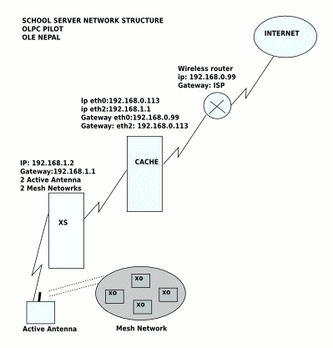
OLE Nepal—OLPC Pilot
Sulochan Acharya

For Routing

# vi /etc/sysctl.conf
make
net.ipv4.ip_forward = 1
service network restart

Then ip-forwarding through ip-tables

# iptables --table nat --append POSTROUTING --out-interface eth0 -j MASQUERADE
# iptables --append FORWARD --in-interface eth2 -j ACCEPT

squid
install and cofigure squid
--------------------squid.conf-------------------------------------
http_port 3128 transparent
hierarchy_stoplist cgi-bin ?
acl QUERY urlpath_regex cgi-bin \?
cache deny QUERY
acl apache rep_header Server ^Apache
access_log /var/log/squid/access.log squid
hosts_file /etc/hosts
refresh_pattern ^ftp: 1440 20% 10080
refresh_pattern . 0 20% 4320
acl all src 0.0.0.0/0.0.0.0
acl manager proto cache_object
acl localhost src 127.0.0.1/255.255.255.255
acl to_localhost dst 127.0.0.0/8
acl SSL_ports port 443 563 # https, snews
acl SSL_ports port 873 # rsync
acl Safe_ports port 80 # http
acl Safe_ports port 21 # ftp
# Add more acl rules here if we want more
acl purge method PURGE
acl CONNECT method CONNECT
http_access allow manager localhost
http_access deny manager
http_access allow purge localhost
http_access deny purge
http_access deny !Safe_ports
http_access deny CONNECT !SSL_ports
http_access allow localhost
acl lan src 192.168.0.113 192.168.1.0/24
http_access allow localhost
http_access allow lan
http_access deny all
http_reply_access allow all
icp_access allow all
visible_hostname sugaroffice.ole
always_direct allow all
coredump_dir /var/spool/squid

Direct port 80 requests to squid listen port (On the machine runnning the cache server)

iptables -t nat -A PREROUTING -i eth2 -p tcp --dport 80 -j DNAT --to 192.168.0.113:3128
iptables -t nat -A PREROUTING -i eth0 -p tcp --dport 80 -j REDIRECT --to-port 3128

