SIMPLE EVALUATION OF THE XO PILOT PROJECT IN BUNGOMA WEST-OLPC INITIATIVE-JULY 2010
PICTURES OF CLASS WHEN IT IS ONE LAPTOP PER CHILD. 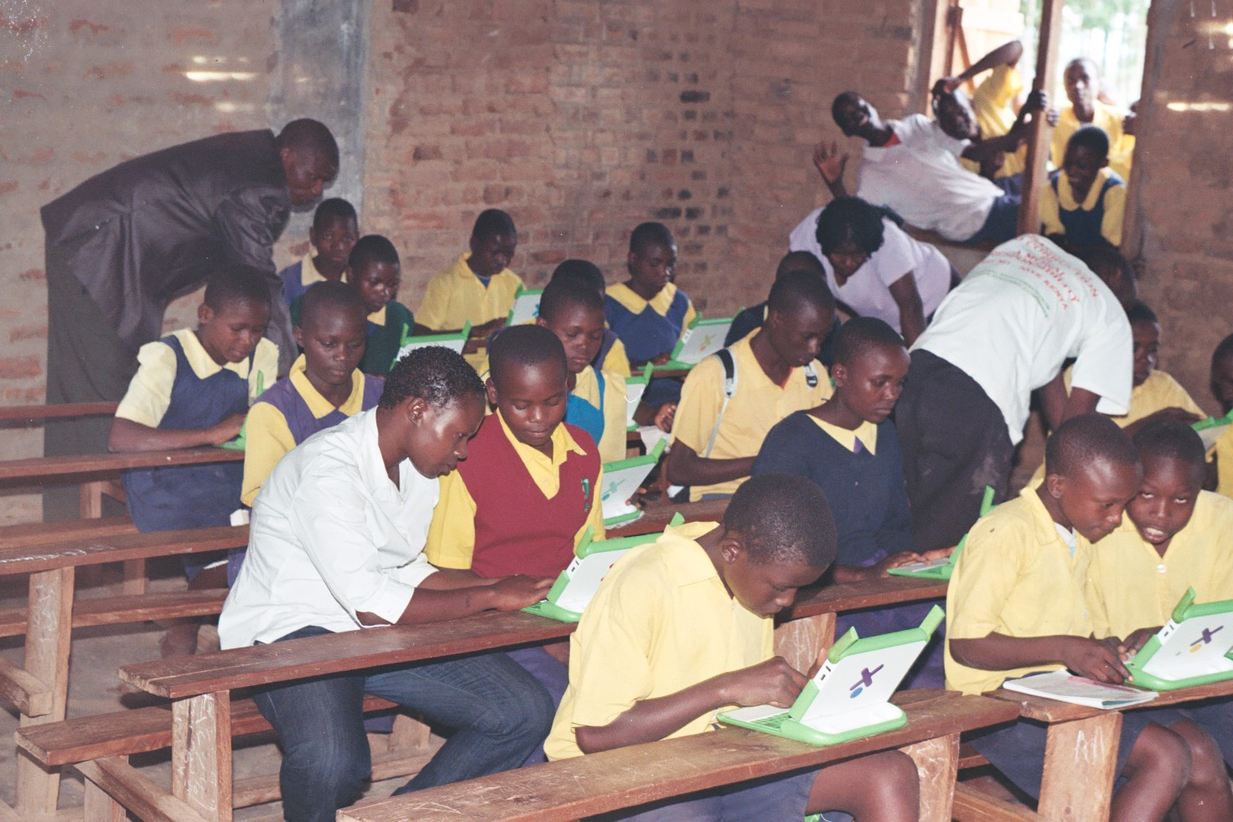
STD VII pupils with teachers/volunteers; Caro,Bonventure,Peris and Fred(Projec manager) at Bukokholo Primary Sch. For HIV/AIDS Evaluation class.
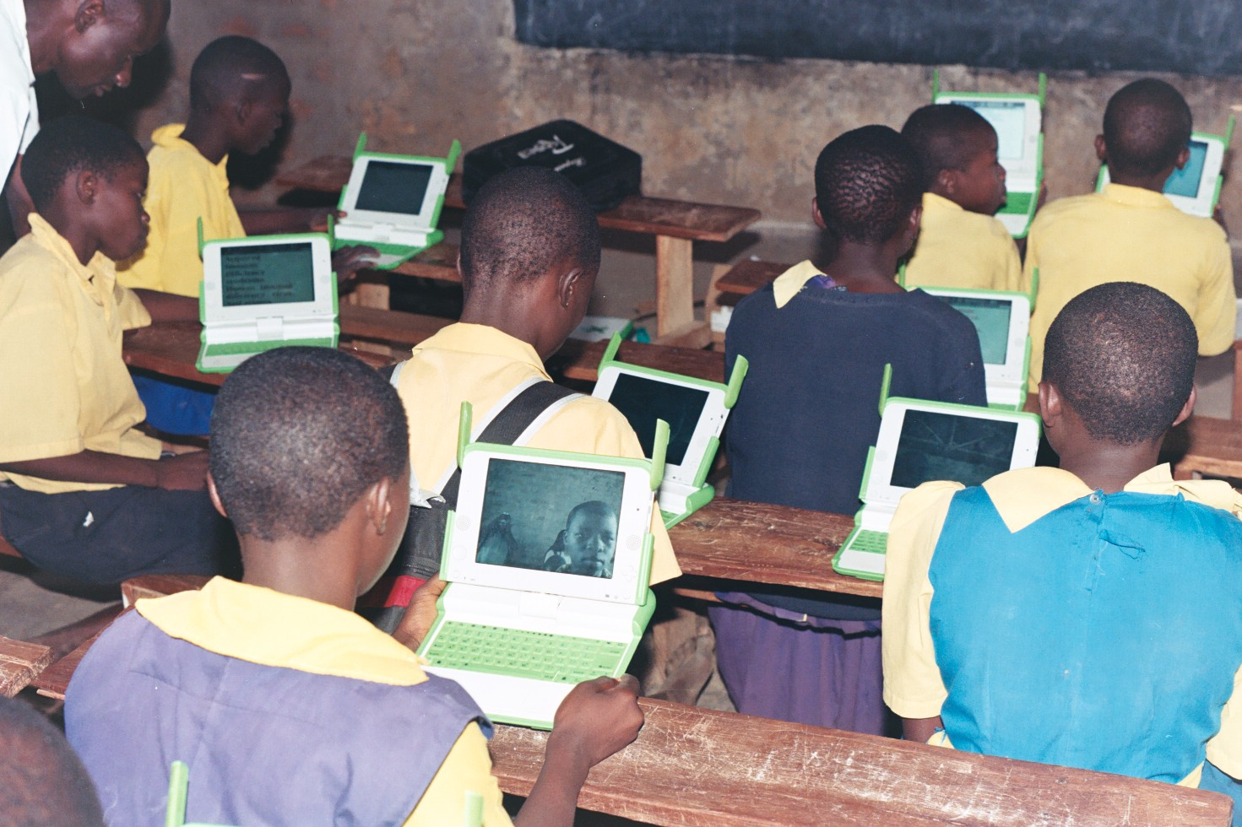
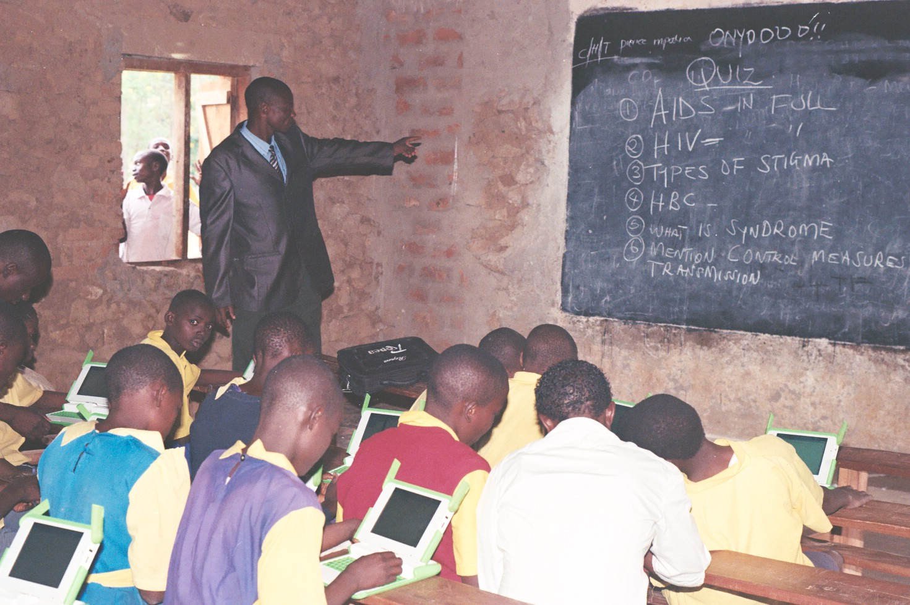
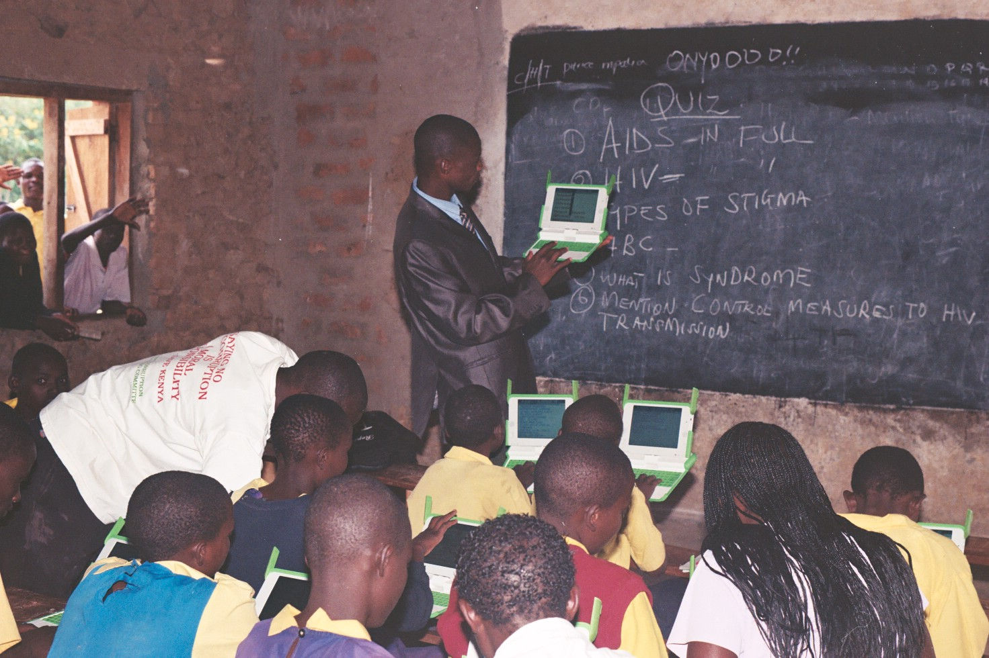
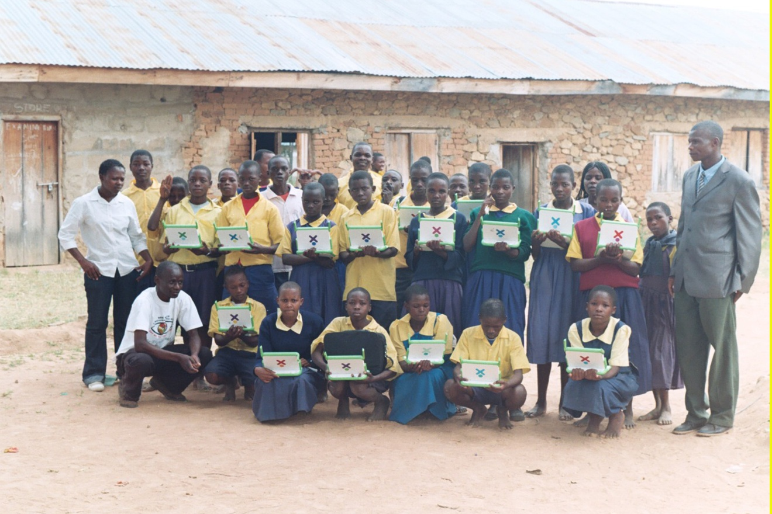
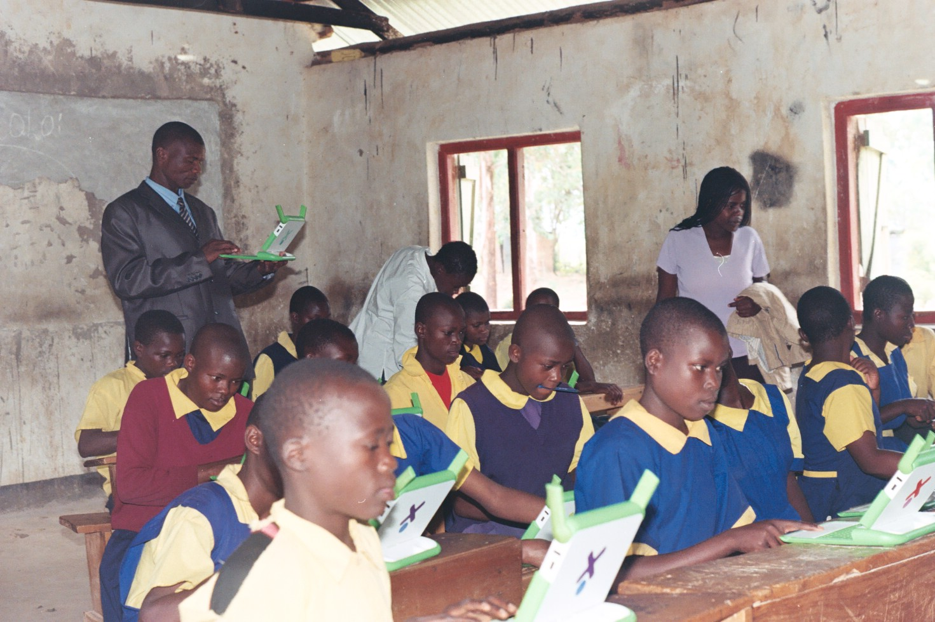

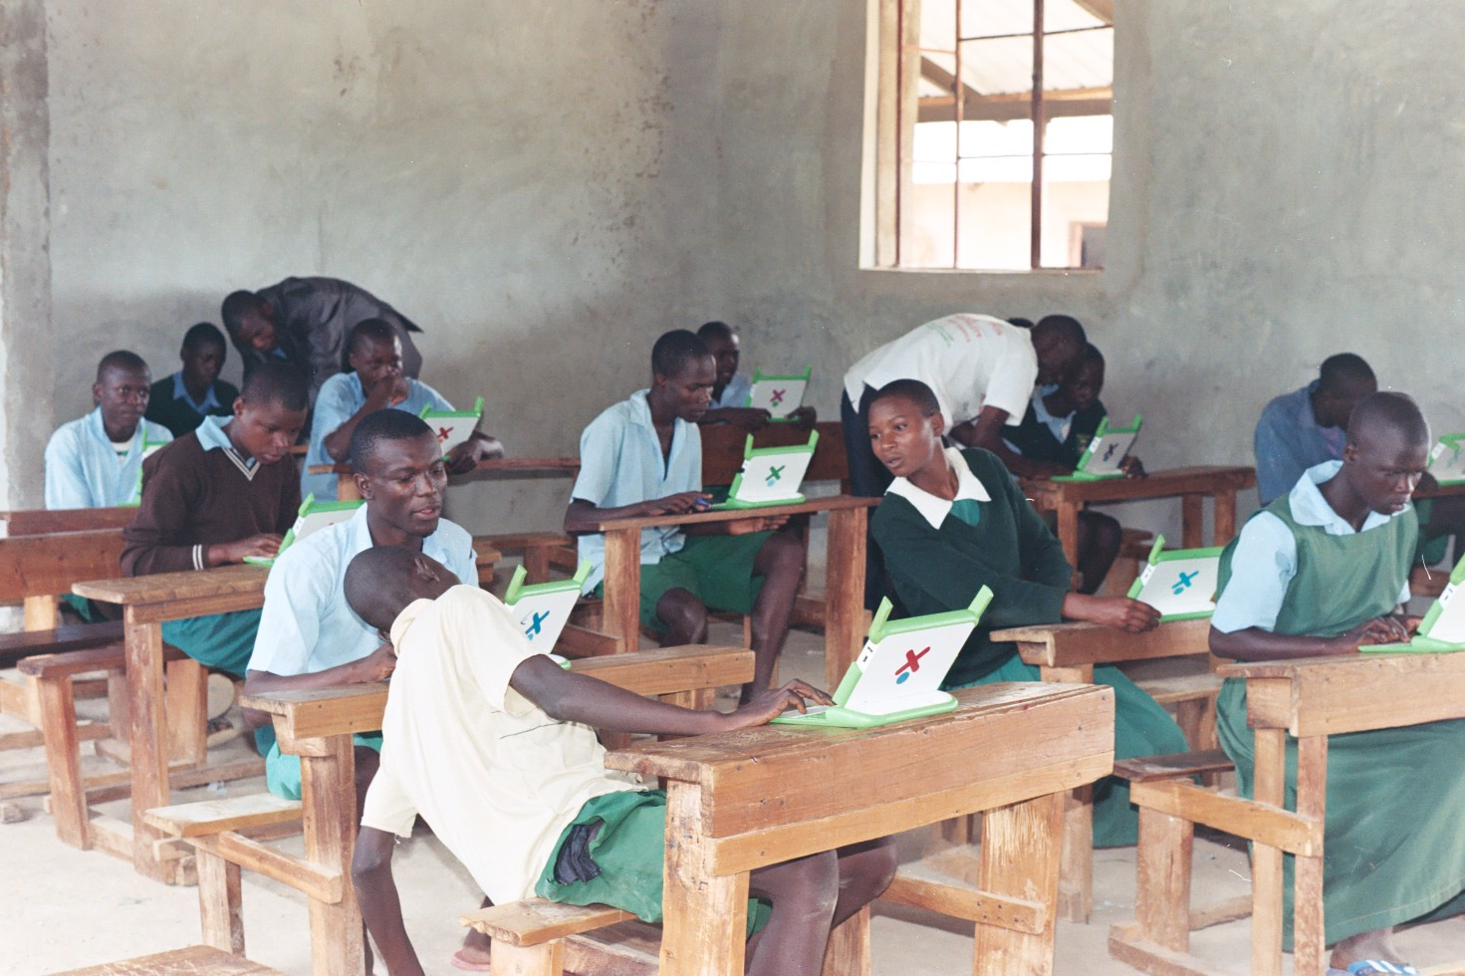 Maths pupils at Butonge with Teachers .

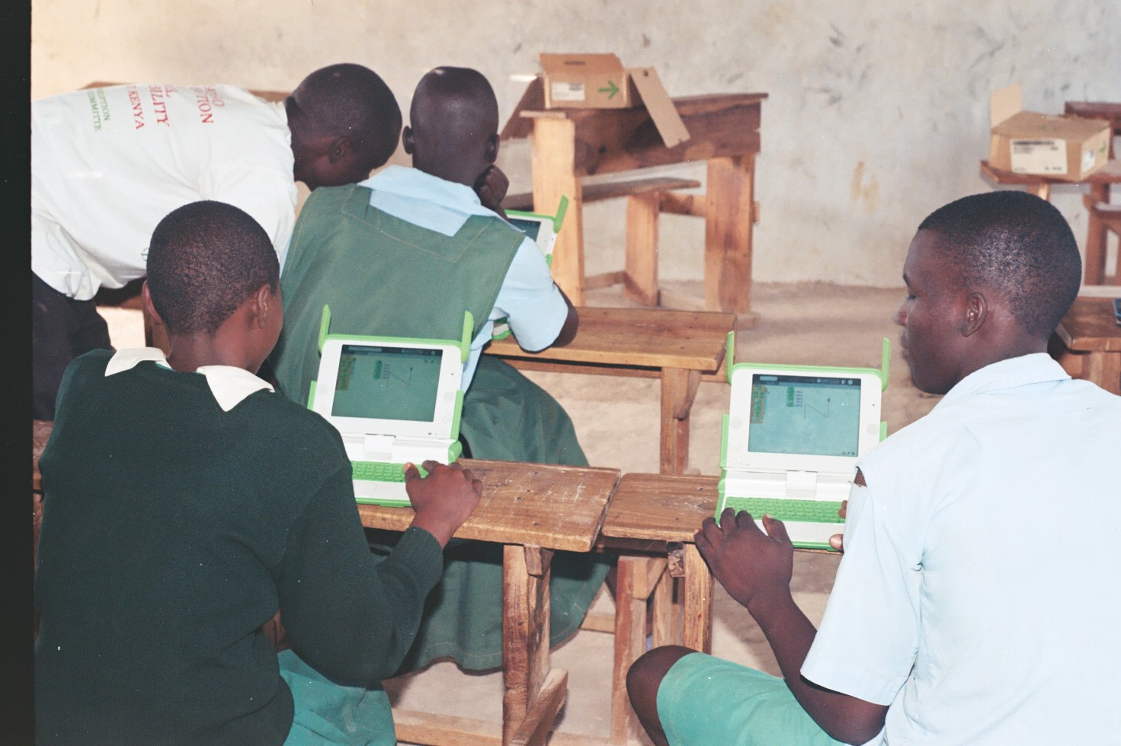 MATHS Curriculum on turtle Art project at Butonge pri. Sch. In Bungoma with teachers

