A NIGHT OF MUSIC, DANCING, FOOD AND GOOD VIBRATIONS
TO SUPPORT ONE LAPTOP PER CHILD IN AFRICA
A CHANCE FOR CHANGE FOR AFRICA
African Dress Preferred

THE MOST HIGHLY DESIRED PERFORMERS FROM THIS AREA
PLAY FROM THEIR HEARTS
Mamadou Diop
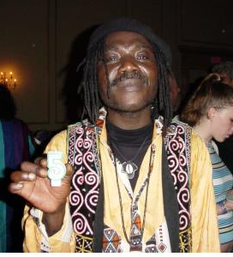
The irresistible energy of master West African rhythm guitarist and drummer MAMADOU presents a world-class cultural experience. The sound is a guitar and drum led groove that includes the rhythms of high-life, juju, rumba, samba, salsa, and reggae blended with authentic Senegalese ethnic rhythms. Though MAMADOU's songs are sung in several languages, the language of music is universal and every audience they perform for instantly understands --and reacts with joyous dance.
-Mamadou Diop was awarded "Humanitarian of the Year" by the Art of Living Foundation and the --Commonwealth of Massachusetts.
-Mamadou Diop has over 30 years of experience performing live for audiences around the world.
As a rhythm guitarist, Mamadou Diop ranks among the best in the world.
-Mamadou has worked with some of West Africa's most notable musicians including those of Thione Seck, Baaba Maal, Youssou Ndour, and Orchestra Baobab.

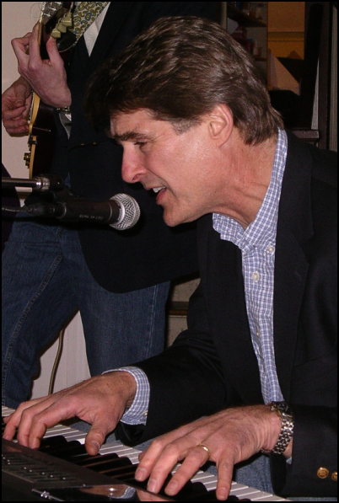
Lark Madden is an extraordinary pianist and guitarist Jazz, interested in mixing the jazz tradition with new harmonies and rhythms, In the process, he has become so proficient at the keyboard that some knowledgeable jazz fans—if forced to choose—would opt for his adventurous piano playing over his dexterous guitar work. Lark Madden can be found at the Unitarian church Newburyport playing guitar and piano in his own bands, and as a sideman with some of Newburyport`s legendary Jazz Instrumentalists and vocalists.
Lark Madden is one of the purest artists I have ever met. He lives for the music. His ability to pick up the changes to any tune instantly, be it on piano or guitar—and fit into any setting— I am correct in categorizing him as one of the 'New Millennium Jazz Lions

Barron Brisset
Vocalist, he sings from the heart and touches ones soul. he always give his 110 in every performance. AMAZING and super talented! Barron Brisset has been thrilling audiences with his heartfelt renditions of well-known standards and unique interpretations of dynamic jazz songs. With a particular dusky soulfulness, Barron Brisset has captured the hearts of critics and audiences alike with just the lilt of his voice.
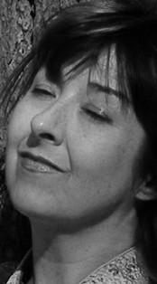
Lisah Plumley
This woman is an angel! All the things about her are the best. She is a singer/songwriter, all her songs rock, and I love every single one of them.
She plays the blues harp. She believes that together we can heal this planet with love and music! She radiates peace, love, compassion, strength, integrity, and outrageous laughter. Her voice is absolutely. She does spirit drawing as a form of intuitive reading, so talented and beautiful. Music and Art have been great healers. For her art is a spiritual practice.

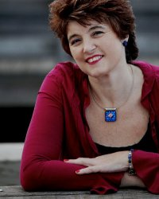
Lucia Vaughn: There is no question about Lucia’s range and control over her voice, which is exquisite. She is without a doubt one of the very best female vocalists. This diva knows how to rock you, not to mention her soulful voice that makes you want to listen to her over and over again.
Lucia is a very wonderful singer her voice is touching and very very very sweet, she is my idol, role model, and motivater. When every I listen to her I get this I can do this feeling.
“Once you heard her singing, you can’t help but sing along! A very beautiful woman!”
She considers herself an Ambassador of Enjoyment. As an event planner, she creates magical, memorable experiences in the private, public and non-profit arenas. She works with small and large projects.

Zach Field Drum Studio
(Kevin and James)

Kevin and James, two young men full of energy, from Zach Field Drum Studio, a New England's premiere drum studio, where you can learn to play the drum set, steel drums and many different types of percussion instruments.
I have seen in Kevin and James and their “Proper Drum Technique”. They execute many variations of grips combined with various finger and arm techniques. They switch techniques several times within a song in order to execute dynamic and tempo changes. The most important aspect of their playing is a natural, relaxed, comfortable motion that produces the fullest range of motion with least resistance. They ring full warm engagement with their playing, and shared joy of African drumming.
Visit zachfielddrumstudios.com.


STELLWAGEN
Jim Grenier and Rob Brunn keeps sounds down to a listenable level, putting acoustic spin on classic & contemporay songs.
At any given show, they are likely to play almost anything, but play it their way. They've been strongly influenced by the jangle bands and folk-rock of the 60s and 70s but they still might launch into Elvis, Bowie, Monty Python, Cat Stevens or Cab Calloway.
Rob Brun is a professional landscape artist, and a sailor. During July and August, he can often be found sailing the coast of Maine on one of his “business trips”, sketching and collecting images for his paintings. Jim's musical influences are as diverse as Tom Rush, The Seldom Scene, The Byrds, The Lovin' Spoonful, Everly Brothers, Paul Simon and The Beatles. He is a fan of open tunings and you'll likely catch him quickly retuning his guitar between songs.

