A NIGHT OF MUSIC AND GOOD VIBRATIONS
TO SUPPORT ONE LAPTOP PER CHILD IN AFRICA
A CHANCE FOR CHANGE FOR AFRICA
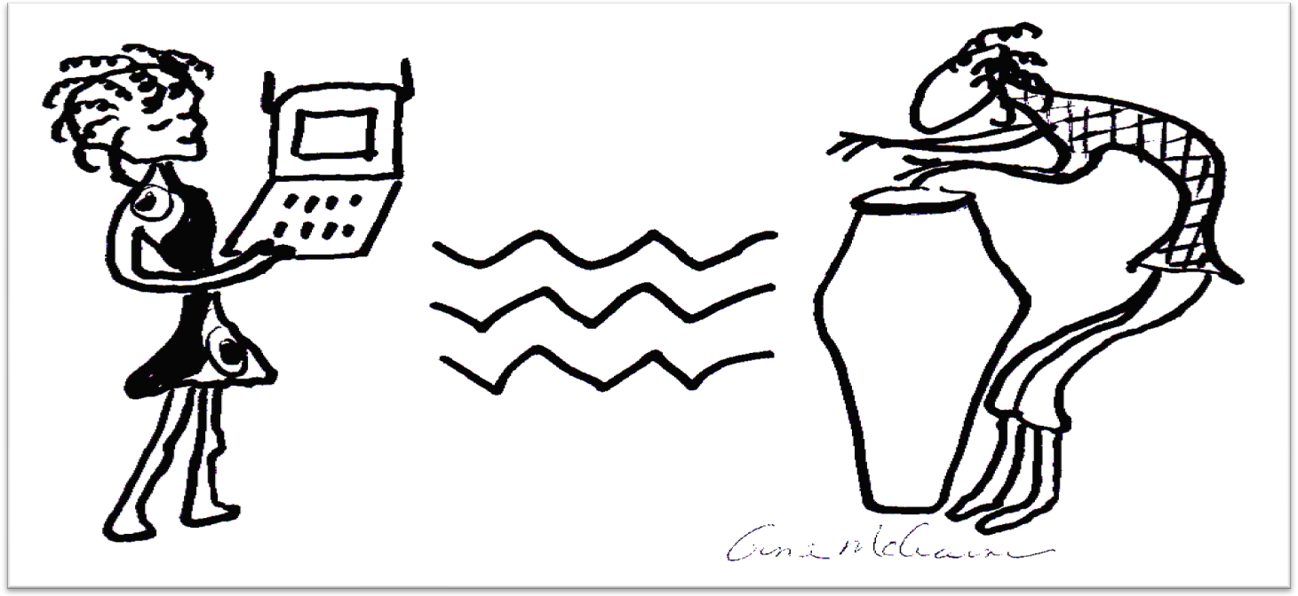

$15

SATURDAY, April 10 5 – 11 PM
Barn Pub & Grille, 5 Ring St Amesbury
Performers: Lark Madden, Mamadou Drums, Lisah Plumley, Barron Brisset
Zach Field Studio Drummers, Stell Wagen and Lucia Vaughn

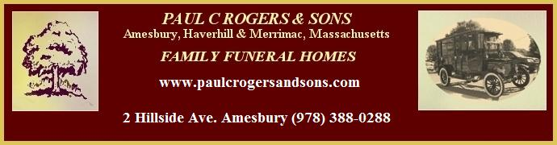
Dress: African look preferred

Contact: SMALL SOLUTIONS (617-320-1098) www.smallsolutionsbigideas.org info@smallsolutionsbigideas.org

