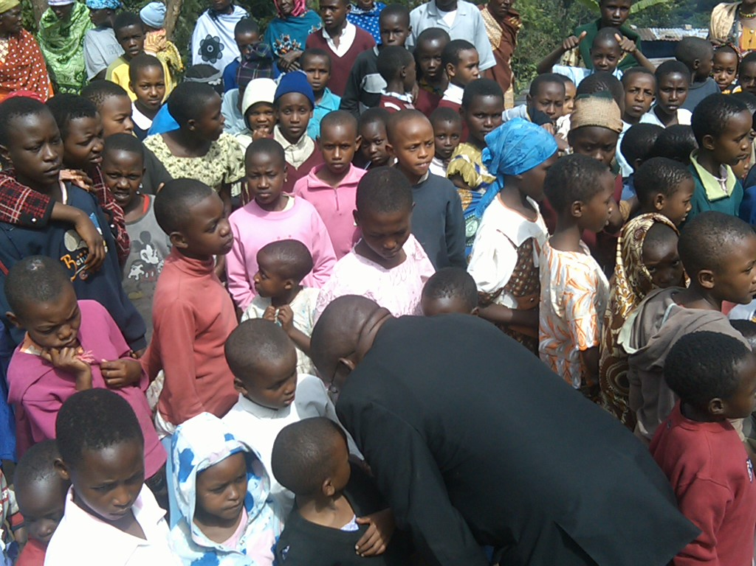 Africa’s Orphans

It’s hard to avoid orphans in Africa. Even where you don’t see them, they are there. When you meet them , there are so many. When you look into their faces there is a sense of a deep silence that is haunting. In Arusha I was hosted by the Reconciliation Ministry. They support several orphan centers by providing counseling, school tuition fees, school uniforms and food. We visited these centers. The number of orphans was overwhelming, and the resources for those caring for them were inadequate. Above is a photo of my host and the children at an orphan center 8 kilometers up Mt. Meru. The mountain side is covered with small farms growing bananas and coffee, as well as other small crops. As you drive up and up bouncing along the terrible dirt roads, among the banana trees appear white crosses of the graves of the AIDS victims. In another photo here you will see what they call the widows. These are the grandmothers who are taking care of the orphans. They are uneducated women with few resources to support these children.
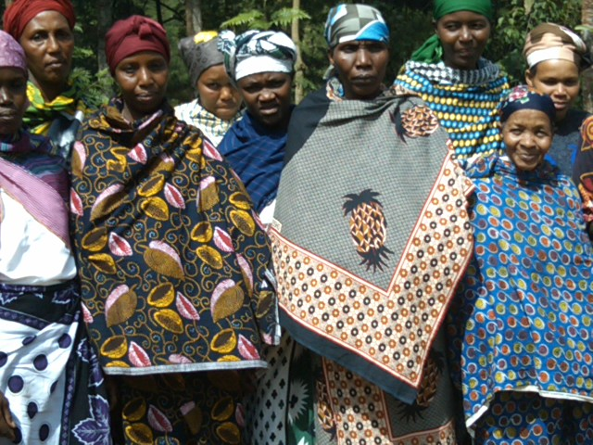

This group presented me with a long proposal for supplying some vocational support for students who did not pass the exam for secondary school. It was difficult to explain to a church filled with 300 or more faces that I was only hoping to supply XO laptops for education. To them this offer must seem mysterious and not so relevant. But I said that I would put their information on our website and look for a community or church that might be interested in supporting their center called Ndoombo. The widows asked for more sewing machines so that they can support the orphans.

The World Bank reports for Tanzania :” Although much has been achieved in curbing the spread of HIV/AIDS in Tanzania, the prevalence rate remains high with seven percent of adults (15-49) infected with HIV.
Over ten years, nearly 20 percent of a sample of children (in a study group) with both parents alive in 1991-94 had lost one parent by age 15.”

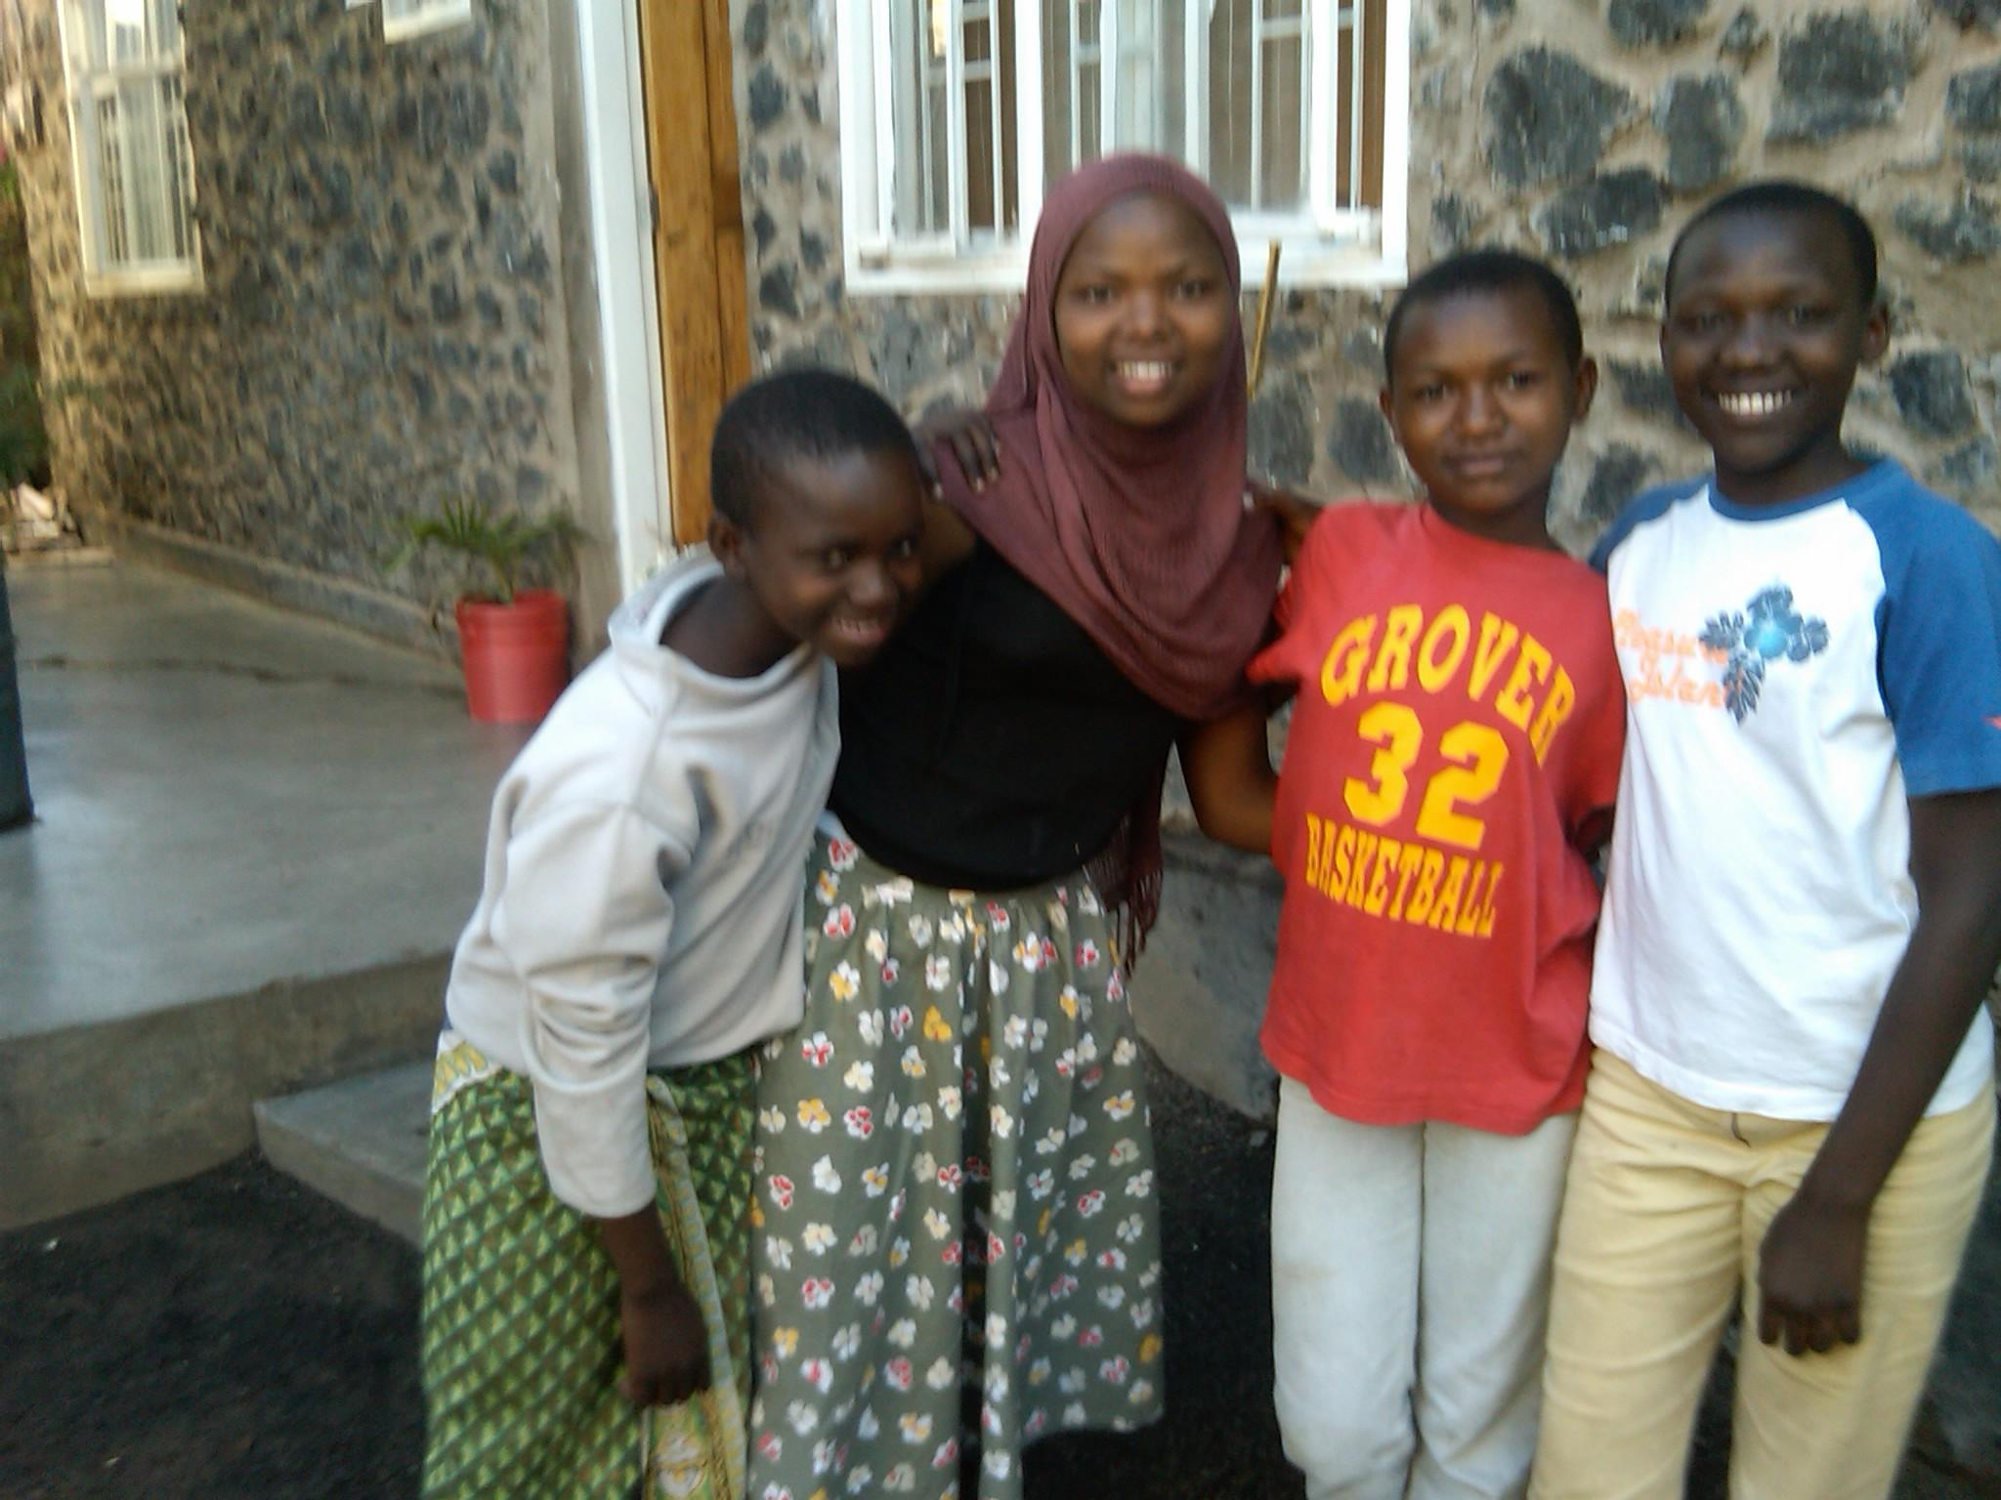
One of the centers we visited did have a well setup support system. It is managed by a Danish non-profit who built attractive stone residential buildings and common spaces and cooking facilities. The Danish organization grew out of some Danes who lived in the neighborhood and were often at a local bar. I was told that every night these children were at the bar looking for food. Eventually the Danes decided that they had to do something for the children. I think that there are twenty or thirty children in the center from the ages of 4 through 17. The non-profit provides a rotating set of volunteers. These children did seem engaged and responsive to the caregivers and even to visitors they didn’t know. See the photo with students clustered around the XO. They responded better to the XO activities than some of the classroom students. Here is a link with more information http://www.tanzibarn.dk/weblogtz/. Some of this is in English. Below are some of these children.
For Tanzania, I thought that we should help Reconciliation Ministry create a consortium or cooperative of orphan centers and community based organizations supporting orphans and provide XOs for all these children. They all need a leg up, and driving change by selecting the most disadvantaged group can stimulate demand for the better positioned children.

In the Taita Hills villages where I stayed with a woman who has been working in community health services and HIV/AIDS for years, I asked her what she thought the percentage of orphans was in the local under 18 population. She said that unless someone asks for services for a child who has lost one or both parents to AIDS it is hard to find and count them. She thought that the number was more than 10% and could be even closer to 20%. We visited some orphans who recently were picked up by a Sister City program (two of the group below). The school director said that these students were very attentive to everything people said, as they are trying hard to understand their lives and future.
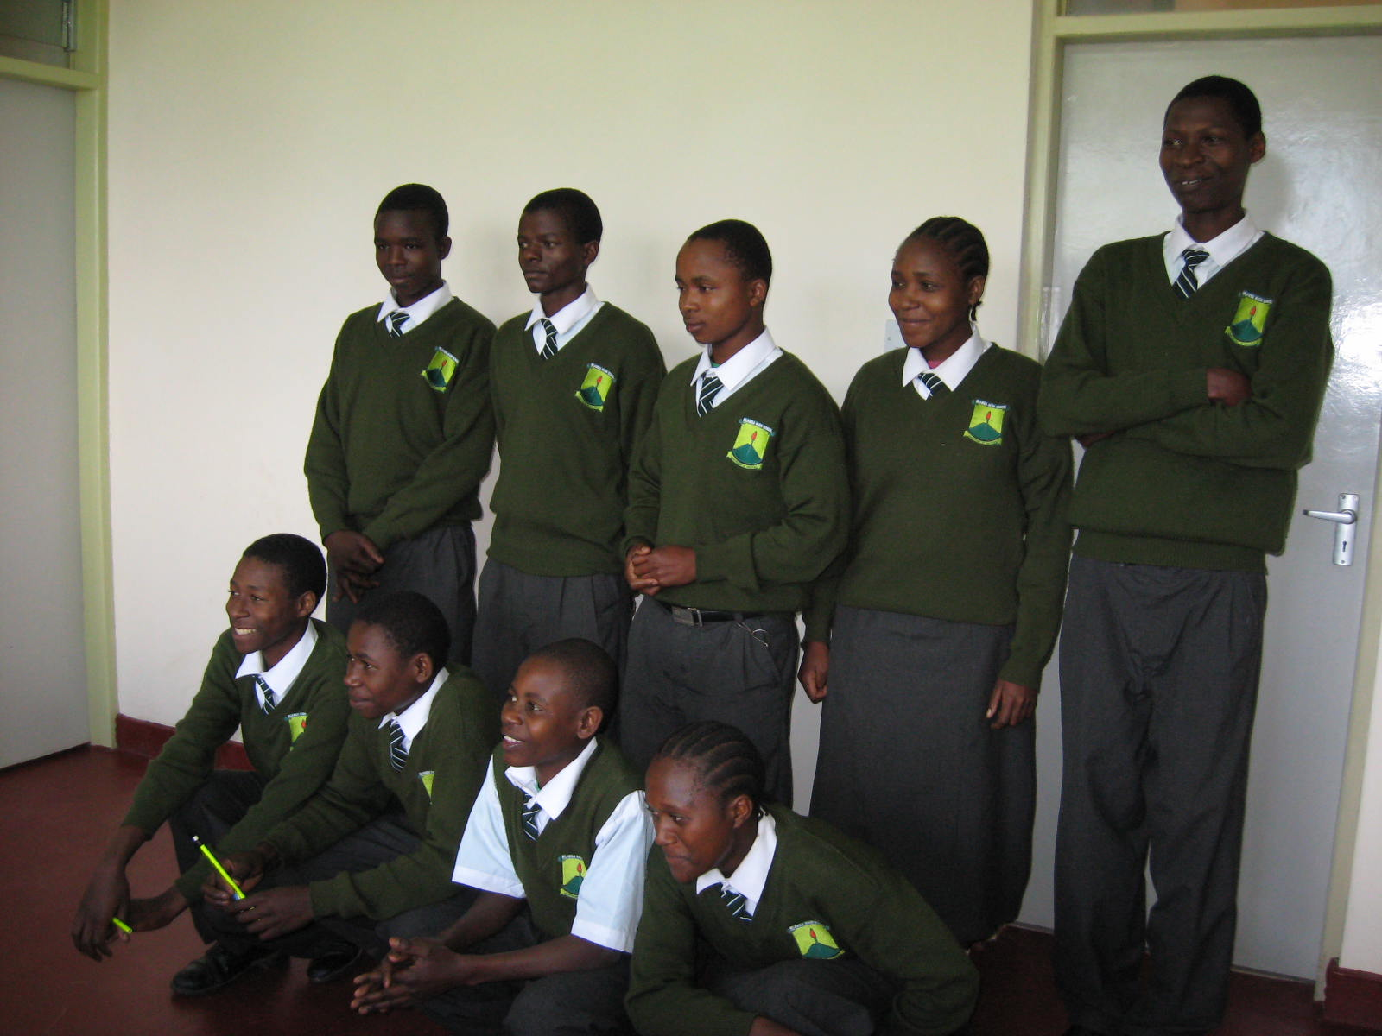

These students are all orphans attending a new secondary school up on a hilltop in the Taita Hills. The school is very beautiful, but only four or five classrooms are supplied with equipment. The rest are empty waiting for funds or donations to get desks, supplies, or books for the library.
