Chinese History Lesson Plan
Connecting the Past and Present

A study of Chinese landmarks in and the royalty who lived in them


Part I.

Today, you and your group will be researching the following landmarks that were significant during the Qin Dynasty. You may use Google on the Browse activity to find out more about them.

The Great Wall of China
The Terracotta Army
Xianyang Palace
Epang Palace
Ling Canal


Part II.

Using the WikiBrowse activity, search for your landmark and write answers to the following questions.

What year was it built?

Why was it built?

How was it used?

What is it like today? Can tourists visit?

Download a picture of your landmark by copying it and saving it in the journal.

Part III.
Open the Map activity and search for your landmark by city and country as shown below. Use an exact address if you have one. If the landmark no longer exists, approximate the location.

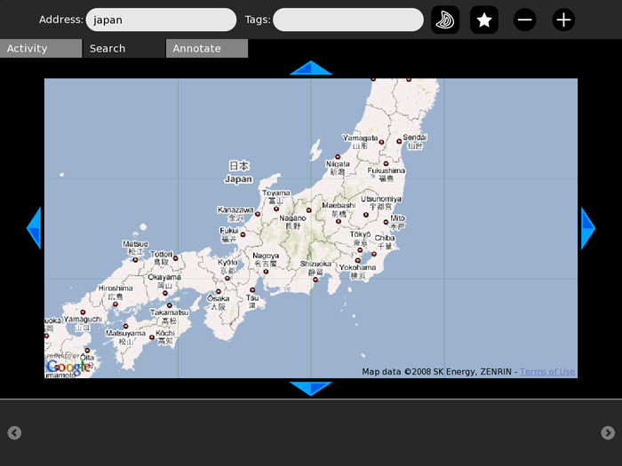

Now, you can tag your landmark with a picture and the information you learned!
Click “Add Media.”

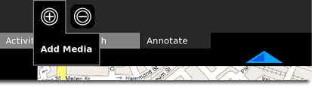

Click on the photo you downloaded.

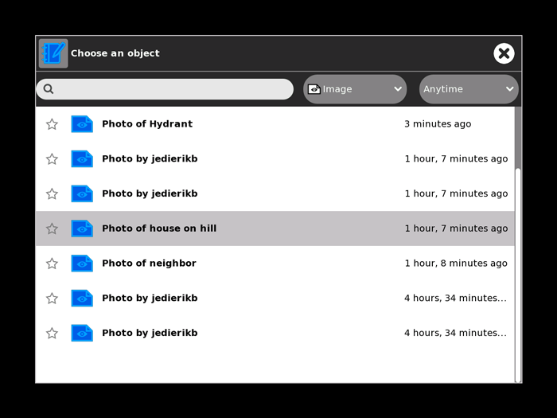

You can then add the text that you wrote describing your palace. Your map is tagged!

