
Springfield, Illinois - March 6, 2008

The Illinois House Computer Technology Committee Passed the
Children’s Low Cost Laptop Fund, House Bill 5000

Click on link here for more detail on this bill:
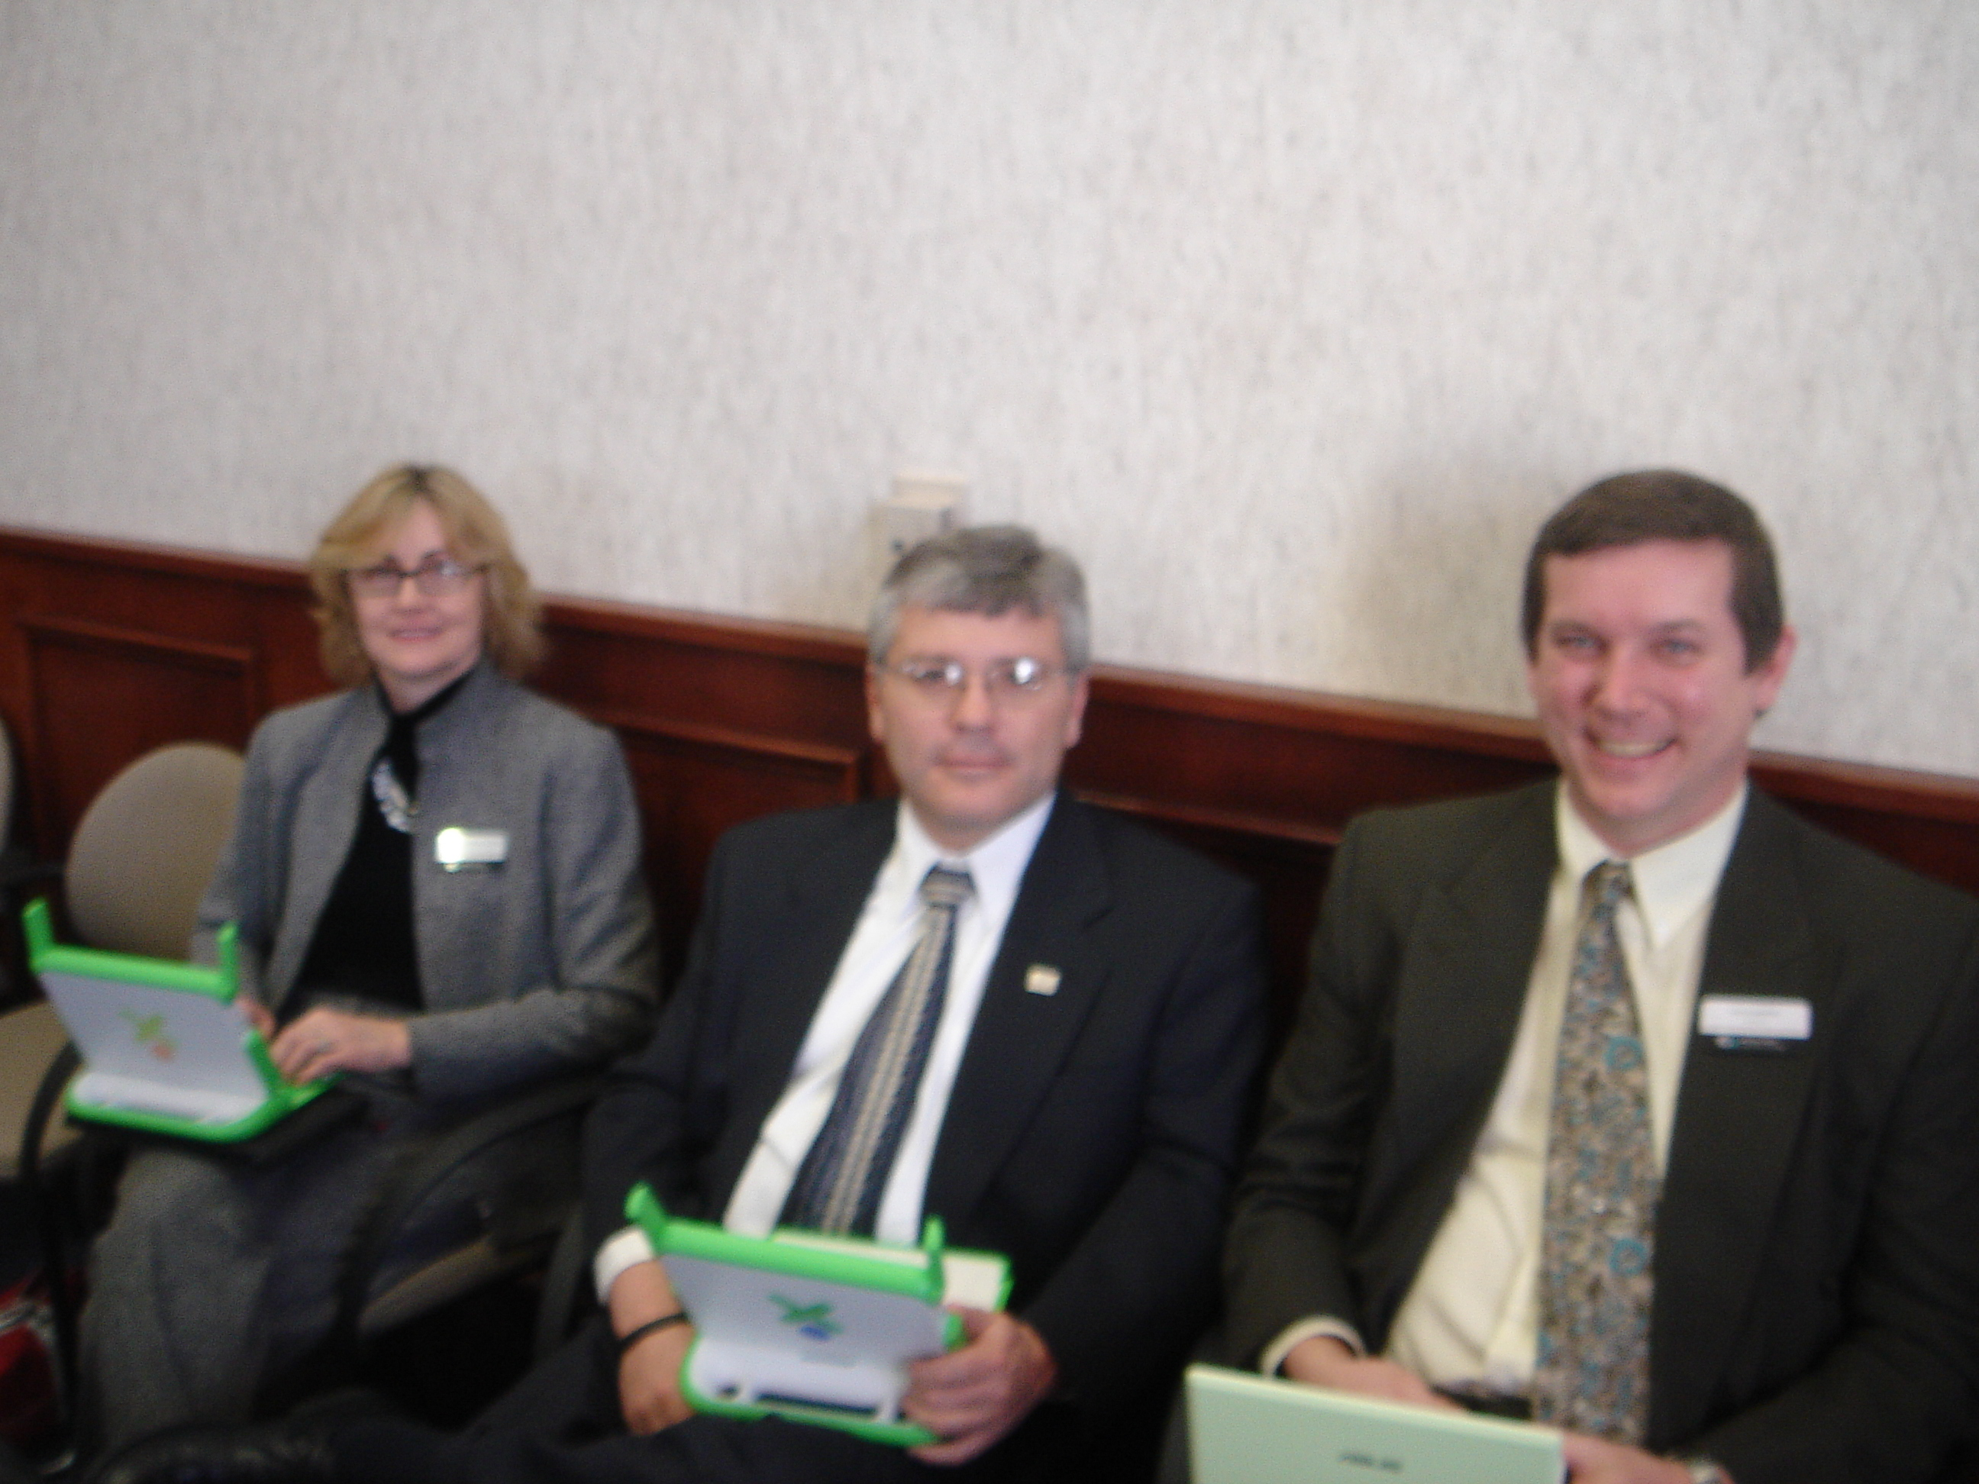
http://www.ilga.gov/legislation/BillStatus.asp?DocTypeID=HB&DocNum=5000&GAID=9&SessionID=51&LegID=35963

The Children’s Low-cost Laptop Act, as currently written, would provide up to $100 million for the creation of a low-cost laptop pilot project for elementary schools in Illinois. The bill will now move to the Illinois House of Representatives for debate.

MVCC Faculty in Attendance:

Larry Langellier, Steve Mastej, and Nancy Woodard

What We Did in Springfield:

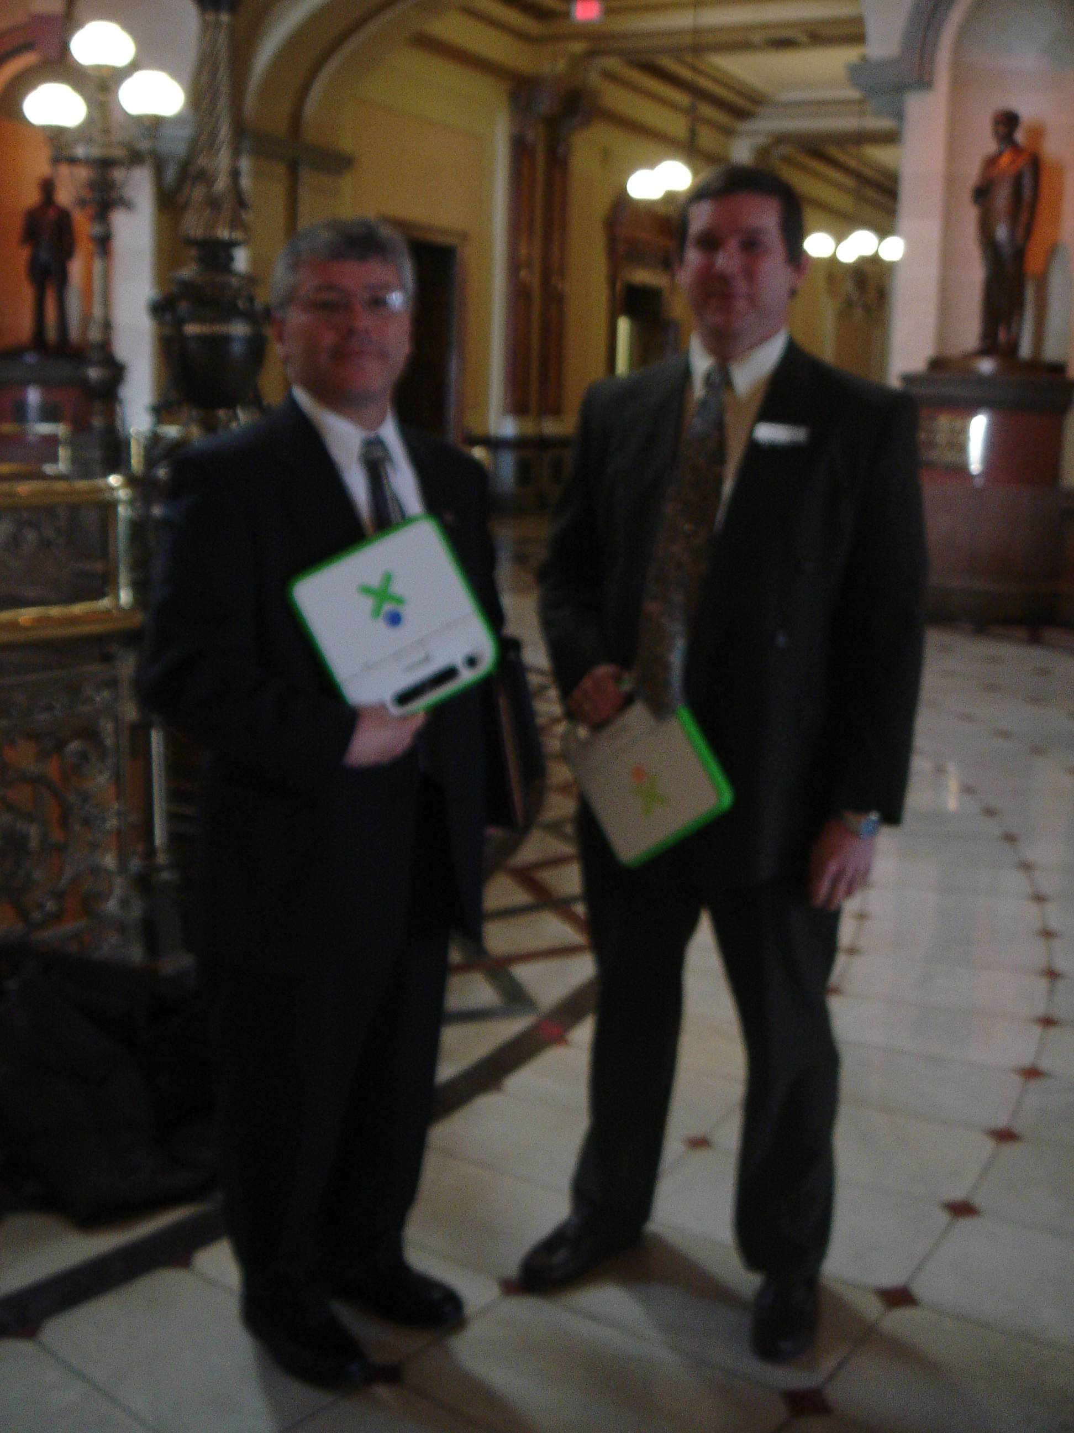
- Attended the Illinois House’s Computer Technology Committee hearing on the Children’s Low-cost Laptop Act – where we witnessed the bill passing out of committee by a 6-0 vote
- Worked with Ryan Croke, Policy Advisor to Lt. Governor Quinn, to fix a broken screen on an XO Laptop that they had – Ryan did the work and completed the repair in 10 minutes
- Met with Lt. Governor Quinn in his office for about 20 minutes to discuss our ideas on how Moraine Valley (and other community colleges throughout Illinois) would be able to:
  - Train and mentor teachers on how to enhance their teaching strategies if every child in their class had a low-cost laptop
  - Advise schools on how to deploy, support, and maintain the necessary server and network infrastructure
  - Provide publicity and fundraising resources

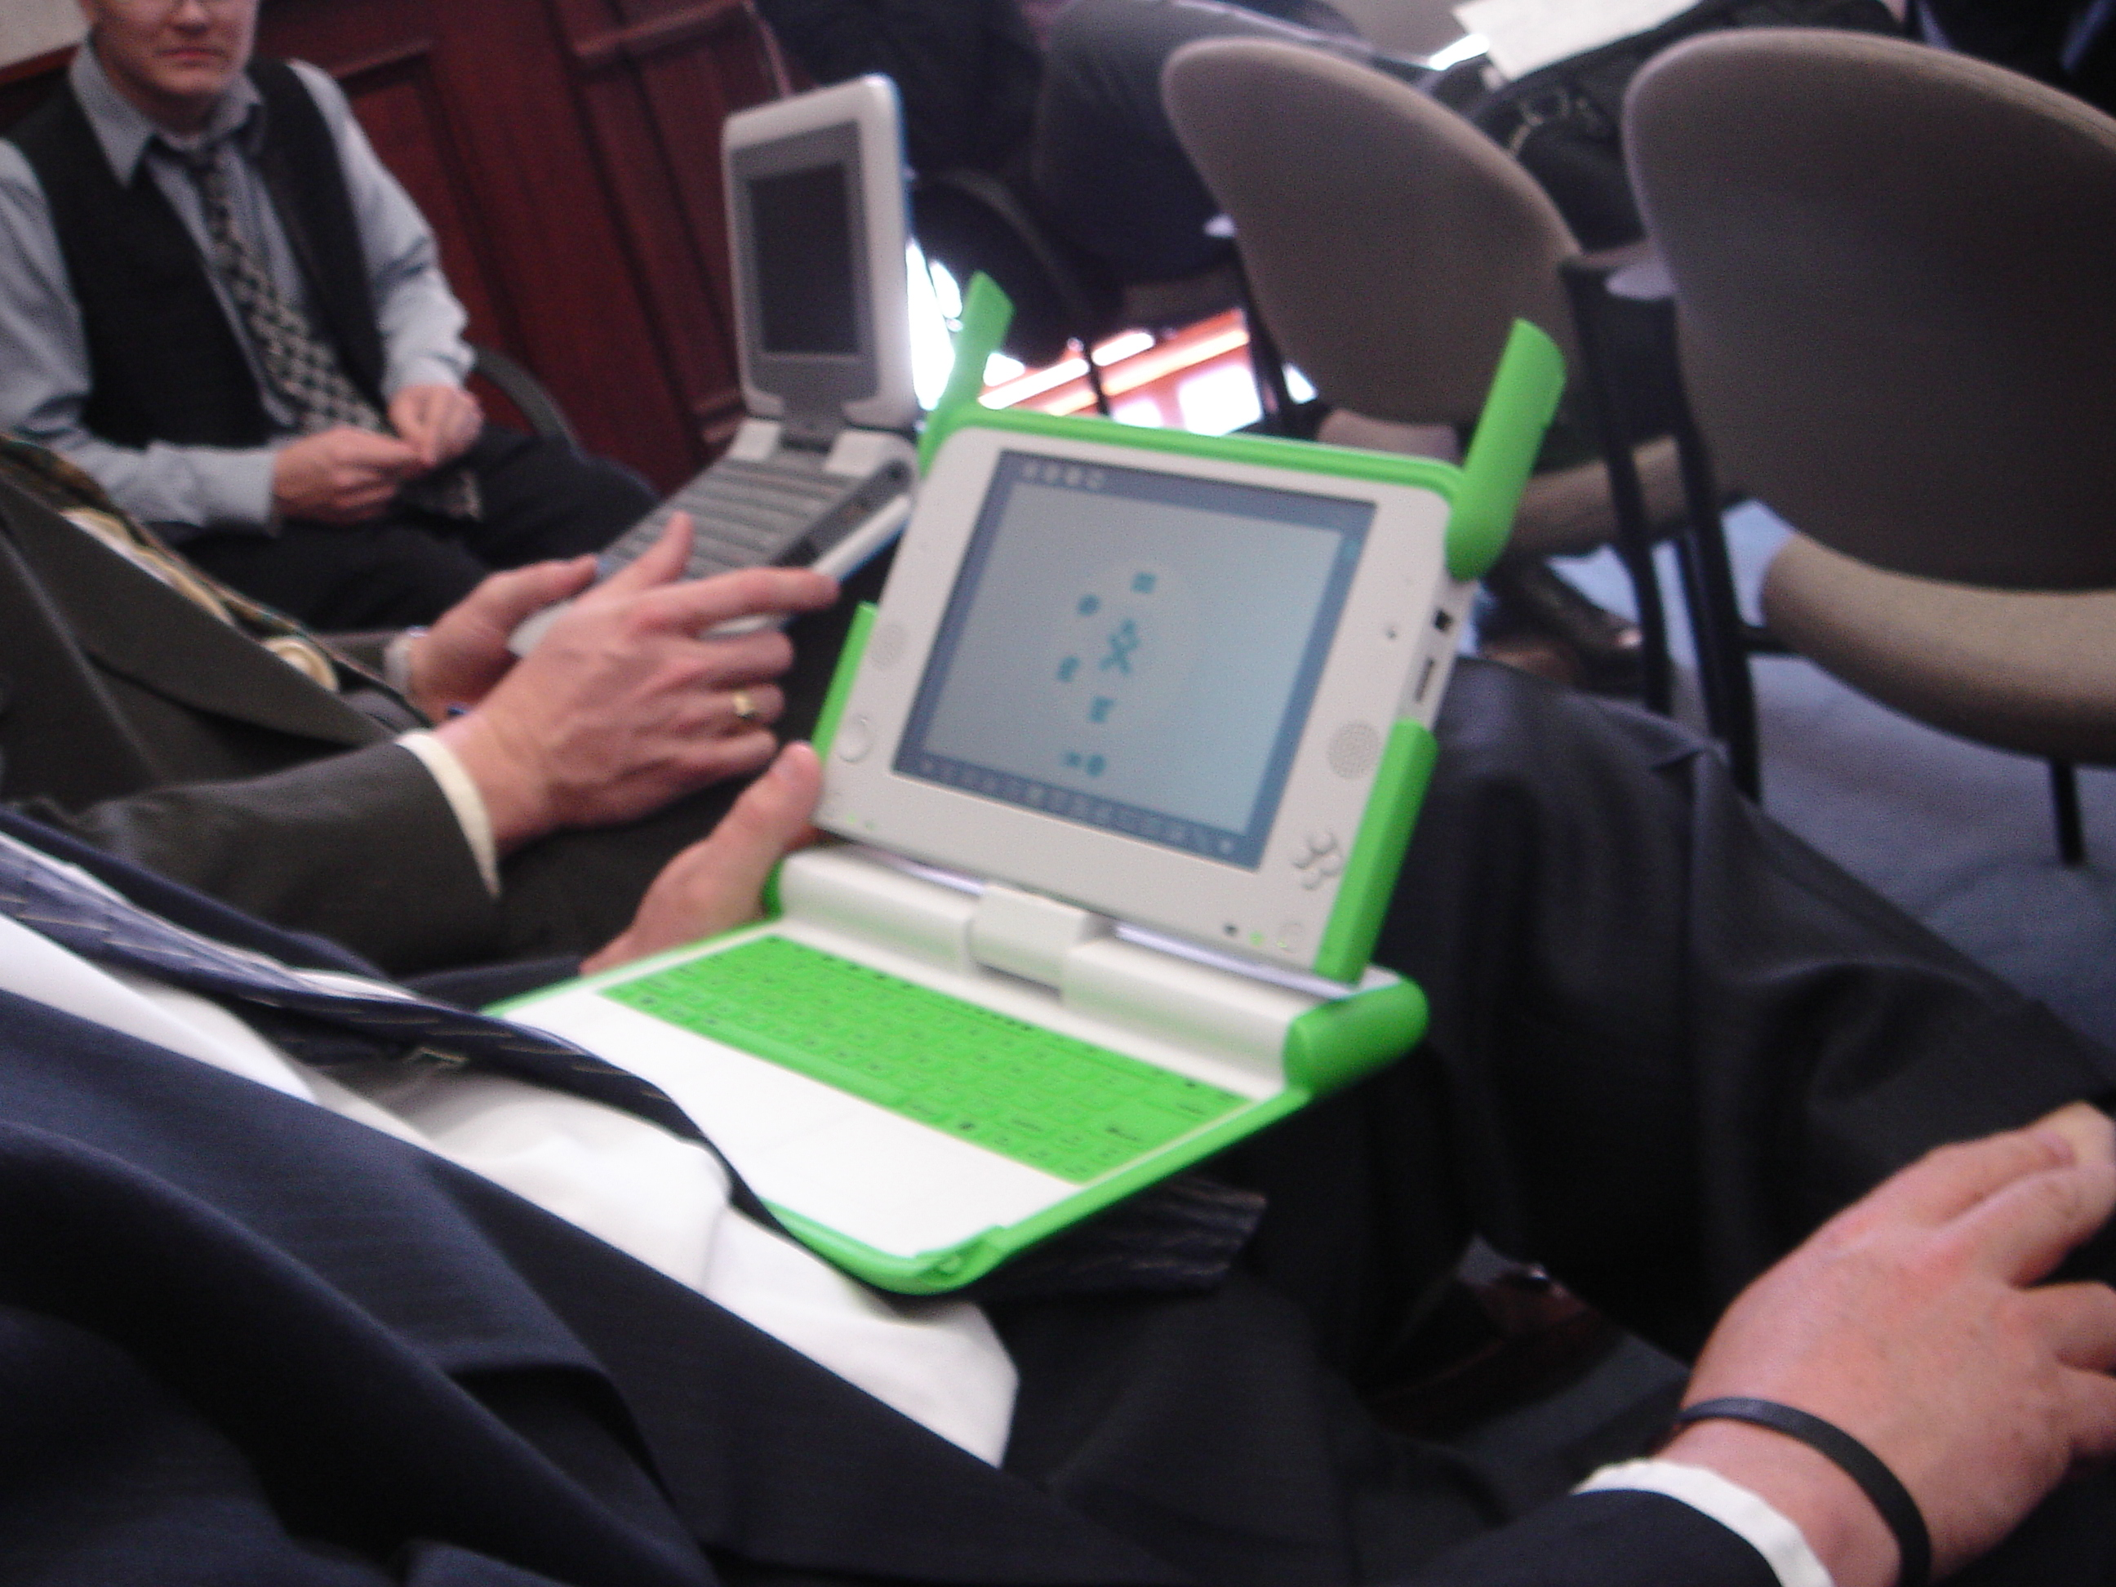
Next Steps at MVCC:

- Determine how to obtain $30-35K to fund a 100+ XO Laptop pilot at MVCC
- Continue campus-wide conversations and organizational planning for the creation of an OLPC Center at MVCC

Some Links to Check Out:

One Laptop Per Child
http://laptop.org (continued on the next page…)

Links to Check Out (cont.):

The XO Laptop: It’s the Software, Stupid
http://w.xconomy.com/2008/02/01/the-xo-laptop-its-the-software-stupid/

Success in Peru (one of the first pilots)
http://radian.org/notebook/astounded-in-arahuay

The First Wide OLPC Deployment
http://radian.org/notebook/first-deployment

FOX News: Uruguay Children Try Low-Cost Laptops
http://wiki.laptop.org/images/5/5e/FOXNews.com_-_Uruguay_Children_Try_Low-Cost_Laptops_-_Technol...pdf

OLPC in NYC – a project of Teaching Matters, KAPPA IV and the NYC DOE
http://olpcnyc.wordpress.com/

Mongolia: The first deployment enabled by the Give One, Get One program
http://wiki.laptop.org/go/Ulaanbaatar

